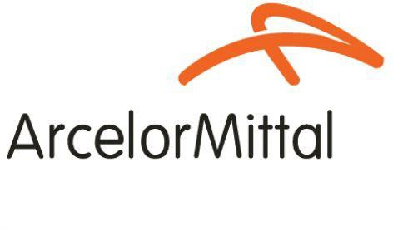
Procedure 2025

ArcelorMittal Building Solutions France Procedure 1.1.1.1
Exchange rates

Software used: Sofie
Source : https://web-treasury.appliarmony.net/

- How to retrieve exchange rates :

Go to: https://web-treasury.appliarmony.net/
  - Click on :

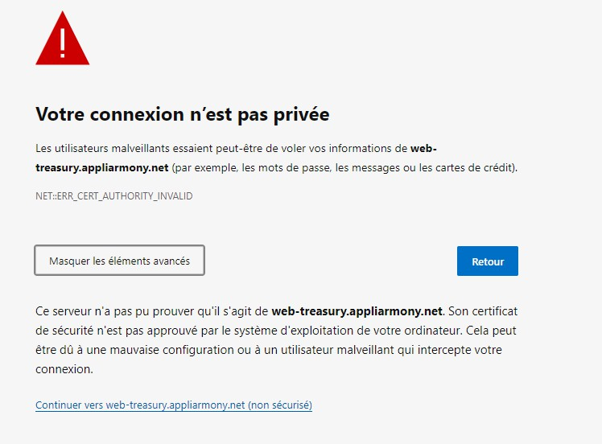
  - Then on :
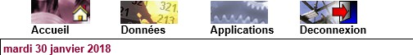

  - Once in DATA, click on spot rates then enter the required dates
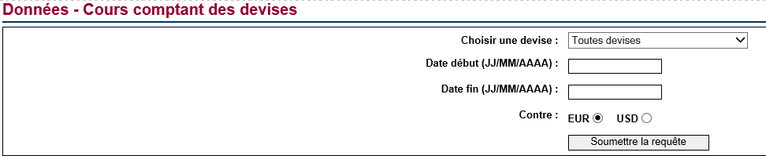

Start date = Today's date ( month end date , 30/31 )
End date = End of next month ( IDEM )
Against: EUR , since we are in the EURO zone

Then click on submit query and print sheets

Please note that currencies are only available on the last day of the month from 4:30 p.m. In Sofie: you must enter the exchange rates generated.

03.Sales management
06. Accounting
08. Currency management
Once in currency management :

- Enter the first business day of the current month
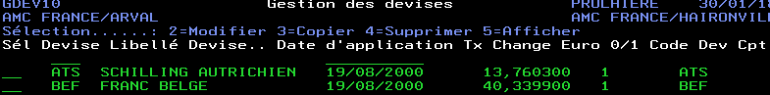

- Copy all currencies by entering the number 3 in the Sel column

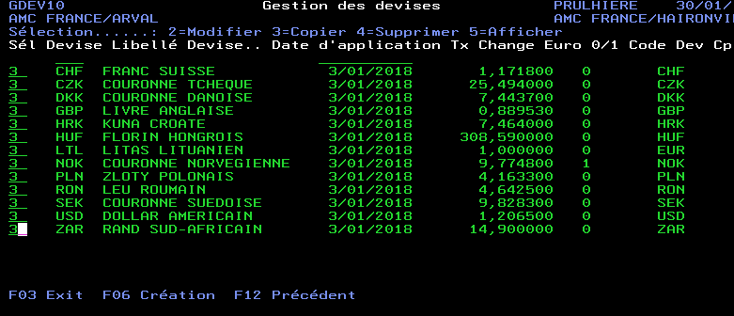

Set the desired application date (first day of the new month)
Set the new exchange rate in the boxes
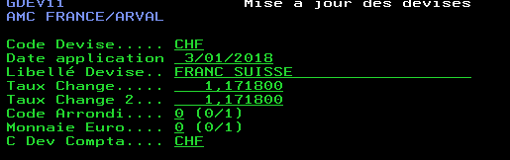
Exchange rate Exchange rate 2

- Validate currencies with F2 and print the sheet in 2 copies. Staple the exchange rates (web) and exchange rates (sofie) and file them in the folder with the date

- Exception: SEK currency is valid for 3 months (per quarter).

Send an e-mail to Eva BOLLENS ( Export ) + Isabelle MAUJEAN .

On: 16/10/2025
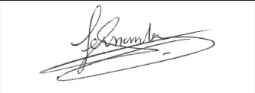
Procedure validated by : S.HERNANDEZ

